**LEBANESE AMERICAN UNIVERSITY**

**USAID – HIGHER EDUCATION SCHOLARSHIP PROGRAM**

**HES - Volunteering Program Verification Form**

This form is to be used to document volunteering hours. If a student volunteers for multiple organizations, a separate form must be used for each organization. **This form must be turned in by the 28th of each month, the latest.**

I certify that the scholar Mariam Harba completed a total of 2 hours of service at Life Sculptor.

The hours were completed hours as per the below:

Hours # 0 (date) _30/09 – 5/10_ (initials of supervisor) __A.K.___

Hours # 0 (date) _7/10 – 11/10_ (initials of supervisor) __A.K.___

Hours # 0 date) _14/10 – 18/10 (initials of supervisor) __A.K.___

Hours # 2 date) _21/10 -25/10 (initials of supervisor) __A.K.___

Brief description of the activities the scholar performed or participated in:

I drafted 20 workshops.  
Draft 10 workshop topics centered around community support for the Psychosocial department.  
Develop 10 workshop proposals that focus on the power of voice for the Life Sculptor Voices department.

Written feedback about the scholar’s performance:

Mariam showcased strong organizational and creative skills by drafting 20 workshop topics, demonstrating her ability to generate impactful ideas for community support.

Please rate the overall performance of the scholar at your organization:

|  |  |  |  |
| --- | --- | --- | --- |
|  | Mastery (5) | Proficient (3) | Emerging (1) |
| **Problem solver** | X |  |  |
| **Engaged & Committed** | X |  |  |
| **Open-minded & multicultural** | X |  |  |

Signature

& stamp

__________________________

_

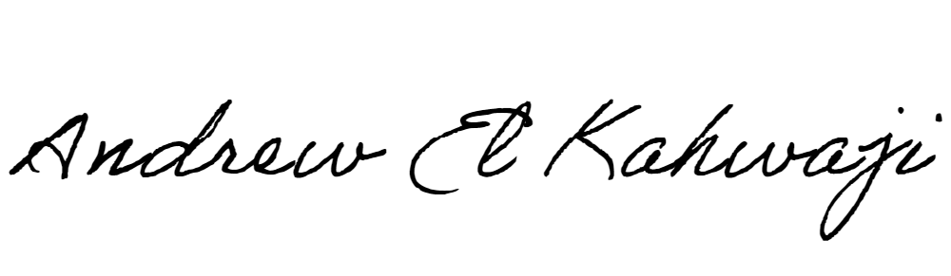

Printed Name _Andrew El Kahwaji_

Date __26/10/2024___

Email __andrew.lifesculptor.coo@gmail.com __

Phone __+961 71 914 378__

**LEBANESE AMERICAN UNIVERSITY**

**USAID – HIGHER EDUCATION SCHOLARSHIP PROGRAM**

